 | Bansilal Ramnath Agarwal Charitable Trust’s  Vishwakarma Institute of Information Technology  Department of  Artificial Intelligence and Data Science
Student Name: Sathe Onkar Abasaheb
Class: TY | Division: B |  | Roll No.: 372078
Semester: II |  | Academic Year: 2025-2026
Subject Name & Code: Cloud and DevOps
Assignment No: II
Title of Assignment: Write and execute Shell scripts (arithmetic operations, loops,
conditional statements).
Date of Performance: |  | Date of Submission:

Aim: To Write and execute Shell scripts (arithmetic operations, loops, conditional statements).
Objective: After the end of the assignment, you will be able to write shell scripts and execute it .
Materials Required: Laptop with Ubuntu installed in it.

Procedure:

What is Shell Scripting?
Shell Scripting: Shell scripting means writing a set of commands in a file (called a script) that the computer can run one after another automatically.
- It uses the Linux/Unix shell (like Bash).
- The script tells the computer what to do — like create files, move folders, check conditions, or run programs.

Open Terminal and perform the following commands
- Arithmetic Operations:
- Creating two variables and performing basic arithmetic operations on it
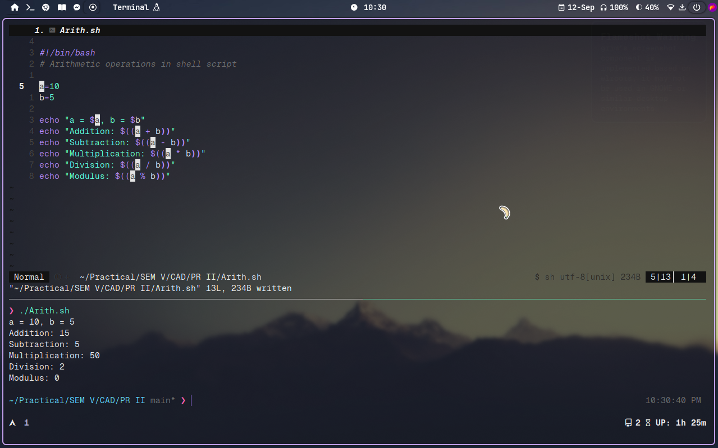
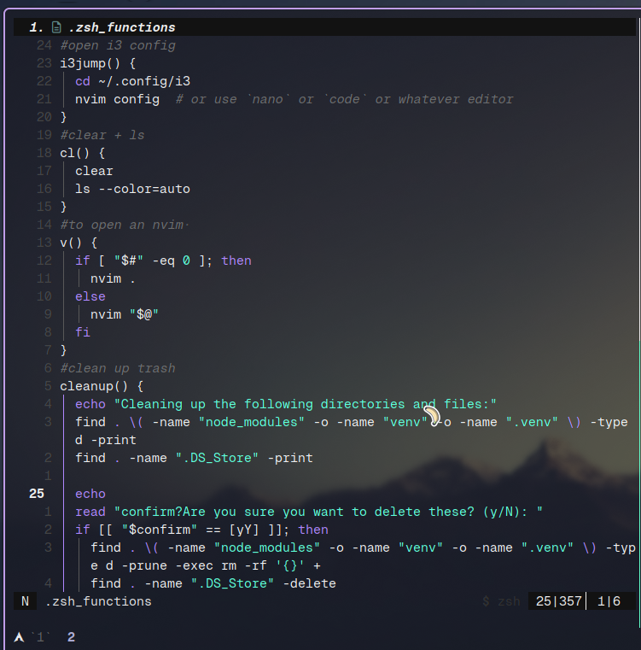
- Printing numbers from 1 to n in loop
Executing if else condition to check it given number is positive or negative.
written more that 50+ functions to manage overall system workflow.
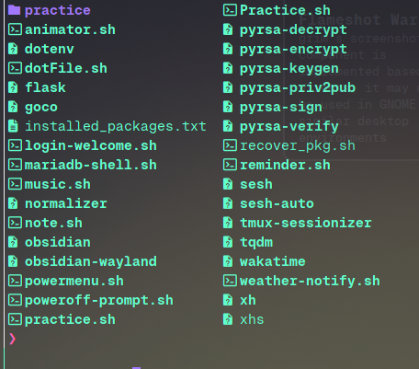

Conclusion: Through this assignment we learnt how to perform basic arithmetic operations, looping statements and conditional statements.

